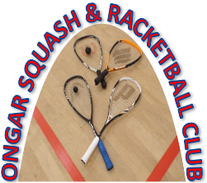
ONGAR SQUASH & RACKETBALL CLUB

Membership Application/renewal for the year to 30 September 2018.
Subscriptions due on 1 October 2017

Name(s): ..............................................................................................................

Address: ....................................................................................................................

....................................................................Post code...............................................

Phone Nos.: Home ............................. Work……………….........…………….........

Mobile: ................................................ E-Mail……………..........…………….........

Facebook account? …..Yes/No…………………………………………………….

Membership Type | OSRC | select
Full Time Adult Membership | £30.00
Full Time Family membership (Two adults + children under 18) | £60.00
Full Time Junior membership (Under 18) | £5.00
Daytime Adult Membership | £10.00
(Off peak before 6pm weekdays & anytime weekends)
Door Key Deposit | £5

Note: A key deposit of £5 is required before a key will be issued to a new member.

A non-refundable charge of £10 will be made for any additional or replacement key.

Total Amount due …………….................

Please Indicate Payment Method: [x] in box

Cheque Please make cheques payable to Ongar Squash Rackets Club

BACS transfer BACs details : Account - 20683884
Sort Code - 20-29-86 Reference [your name]

Cash

Please return the completed form with your cheque/cash payment to:
Dave Honeywell - 7 The Spinney Ongar, Essex CM5 9HP.
Tel: 01277 364523 / Mb 07766 201851 / davehoneywell01@gmail.com

I/We apply for membership of the Ongar Squash & Racketball Club and if accepted agree to abide by the rules of the club.

Signature…………………………………….. Date………………………..

